SC3000: Artificial Intelligence Lab Assignment 2 Report

|  |  |  |
| --- | --- | --- |
| **Name** | **Email** | **Matric Number** |
| **Zhang Yuxuan** | **zhan0654@e.ntu.edu.sg** | **U2321475L** |
| **Bai Yifan** | [**BAIY0026@e.ntu.edu.sg**](mailto:BAIY0026@e.ntu.edu.sg) | **U2320437J** |

**Tutorial Group:**

**Teaching Assistant:**

School of Computer Science and Engineering Nanyang Technological University

2024/2025 Semester 2

# Exercise 1: The Smart Phone Rivalry

**Q1.1**

**Constants:**

1. sumsum
2. appy
3. stevey
4. galactica-s3

**Facts**:

1. Company(sumsum)
2. Company(appy)
3. Competitor(sumsum, appy)
4. developed(sumsum, galactica_s3)
5. stole(stevey, galactica_s3)
6. boss(stevey, appy).

**Predicates:**

1. ∀boss1, ∀company1, ∀company2, ∀tech,

[boss(boss1, company1) ∧ stole(boss1,tech) ∧ developed(company2,tech) ∧ Rival(company1,company2) ∧business(tech)] ⇒ Unethical(boss1)

1. ∀company1, ∀company2

Competitor(company1,company2) ⇒Rival(company1,company2)

1. ∀tech, ∀company2

developed(company2,tech) ) ⇒business(tech)

**Q1.2**

**Q1.3**

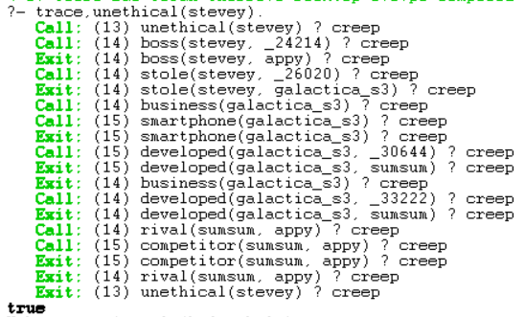

Exercise 2: The Royal Family

**Q2.1**

**Q2.2**

